Project Design Phase-II
Data Flow Diagram & User Stories

Date | 19 February 2026
Team ID | LTVIP2026TMIDS75186
Project Name | Rising Waters: A Machine Learning Approach to Flood Prediction
Maximum Marks | 4 Marks

Data Flow Diagrams:
A Level-0 DFD illustrates how data flows between users, environmental data sources, preprocessing layer, machine learning model, database, and alert system.
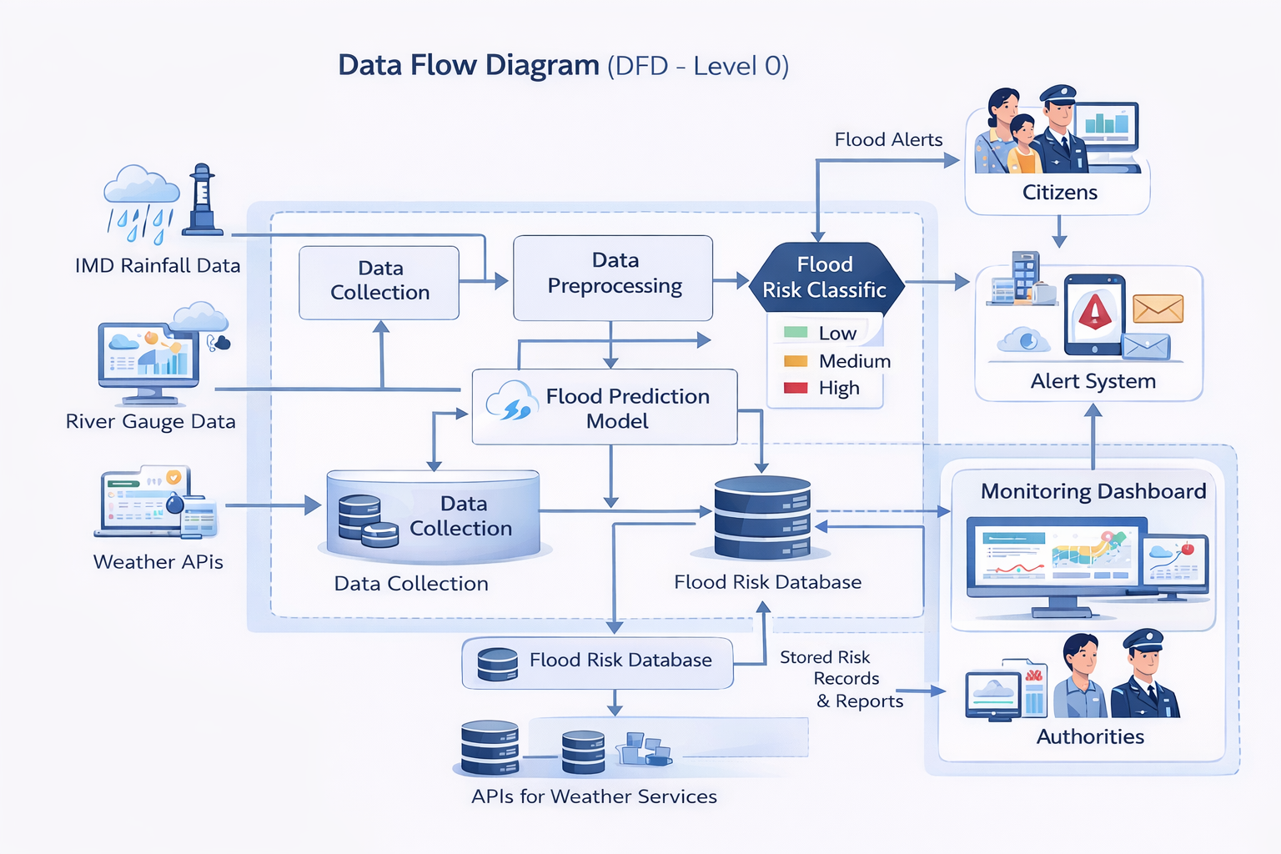
User Stories
Use the below template to list all the user stories for the product.
User Type | Functional Requirement (Epic) | User Story Number | User Story / Task | Acceptance criteria | Priority | Release
Customer (Mobile user) | Registration | USN-1 | As a user, I can register for the application by entering my email, password, and confirming my password. | I can access my account / dashboard | High | Sprint-1
 |  | USN-2 | As a user, I will receive confirmation email once I have registered for the application | I can receive confirmation email & click confirm | High | Sprint-1
 |  | USN-3 | As a user, I can register for the application through Facebook | I can register & access the dashboard with Facebook Login | Low | Sprint-2
 |  | USN-4 | As a user, I can register for the application through Gmail |  | Medium | Sprint-1
 | Login | USN-5 | As a user, I can log into the application by entering email & password |  | High | Sprint-1
 | Dashboard
Customer (Web user)
Customer Care Executive
Administrator

